Turiba University
ALEN FRANCIS

FOUR EYE METHOD

PROFESSIONAL BACHELOR THESIS

Study Programme: Computer Systems

Author: ALEN FRANCIS

Thesis Advisor: Janis Peksa

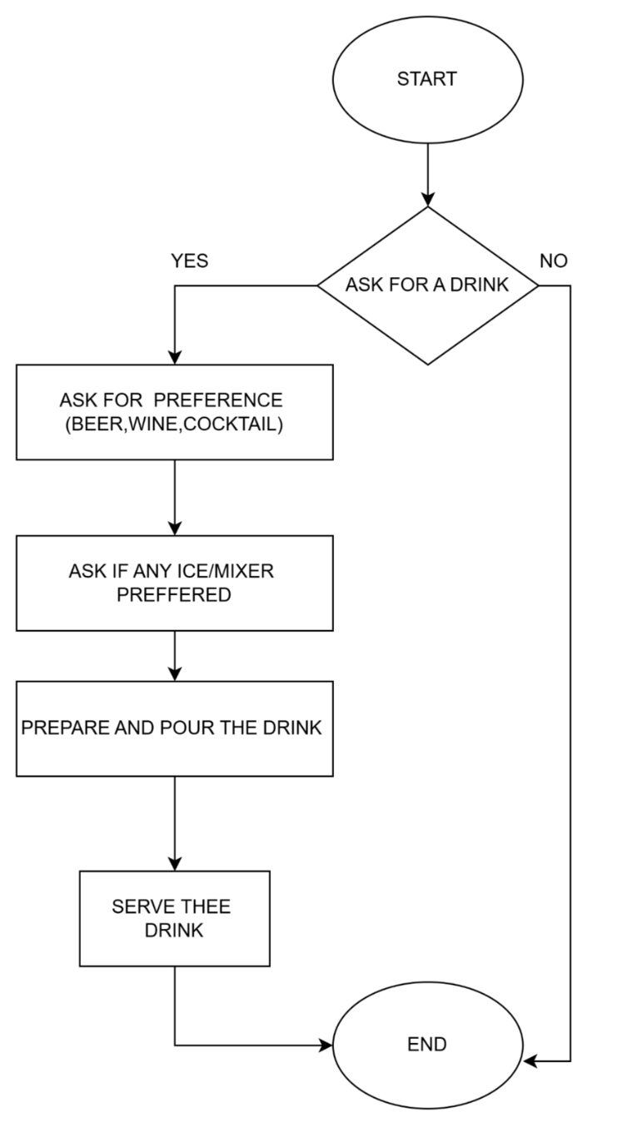 REPORT ON FLOW CHART

CLASSMATE : AJWIN

FLOWCHART : Drinks at party

Pros

1. Clear Logical Flow
The steps are arranged in a straightforward top-to-bottom direction, making the process easy to follow.

2. Proper Use of Flowchart Shapes
- Oval for start and end
- Diamond for decision (Ask for a drink)
- Rectangles for processes
This shows correct flowchart conventions.

3. Covers All Major Steps
You included:
- Asking for preference
- Asking about mixers/ice
- Preparing and serving
This makes the process understandable and complete.

4. Good Visual Separation
Each step is well spaced and easy to read.

Cons

1. Typos in Labels
Examples:
- “PREFERENCE” misspelled as “PREFFERENCE”
- “PREFERRED” misspelled as “PREFFERRED”
- “THEE DRINK” should be “THE DRINK”
These can reduce professionalism.

2. Missing Decision Labels Clarity
The YES/NO labels are small and could be placed closer to the decision branches for clarity.

3. The NO Path Leads Directly to End Without Explanation
The NO branch returns to END but does not show a step like:
- “Do not serve a drink”
- “Return to customer”
This could make the chart feel incomplete.

4. Some Steps Could Be Merged
For example:
- Asking for drink type and mixer could be combined into a single decision block.

5. No Error Handling
What if:
- The drink type is unavailable?
- The customer requests something else?

